HLC International
The Parent Conversation — Master Guide
Value and fee, in one conversation
For class teachers, mentors, family contacts, counsellors and senior leadership · Internal · Not for circulation to parents

What this document replaces
This supersedes both earlier scripts — the value-and-AI counselling script and the fee conversation script. Neither should be used on its own again, for one reason.
A parent who does not believe in the value hears a number. A parent who does hears a price. The entire job of this document is to move a parent from the first state to the second — before the figure is mentioned, never after.
Running them as two separate meetings is worse than running either alone. A value meeting followed three weeks later by a fee letter is experienced as softening-up, and a sharp parent will say so. A fee meeting with the value bolted on afterwards is experienced as justification after the fact. One conversation, in the order set out in Part C.

PART A — The umbrella

The three rules that govern everything below
- Show before you ask. Nothing you promise is worth what one delivered thing is worth. A parent who has already seen an outside judge at a showcase, or received a written Learning Story about their own child, is in a completely different conversation from one who has only heard plans. This is why the free pilots launch first — not as tactics, but because it is the only honest order.
- Say it before they do. Every objection the parent is holding, you already know. Said by them, it is a grievance. Said first by you, in their words, it becomes a shared problem. This single move does more work than any argument in this pack.
- Decide with them, never for them. Give them a route to yes that costs no face, and a real route to object that costs their child nothing. A parent who believes an objection will rebound on their child does not object — they pay, resent, and leave quietly a year later.

Negotiation practice that works here
These are established practices from negotiation and influence research, filtered for what actually holds up in front of an IT-professional parent who negotiates contracts for a living.
- The accusation audit. Name their worst thought out loud, first, and in their language: “A large number in a board year can look like it is being asked because you cannot move him now.” Voicing it removes its charge. Leaving it unsaid guarantees it hardens.
- Labelling, then silence. “It sounds like the timing bothers you more than the amount.” Then stop talking. The pause is the technique. Most counsellors lose the conversation by filling it.
- Aim for “that’s right”, never for “yes”. A “yes” can be polite, cornered or false. “That’s right” means the parent has heard their own position stated accurately and accepted your framing of it. That is the only agreement that survives the drive home.
- Objective criteria instead of assertion. Replace “we are excellent” with things a stranger can verify: Cambridge results as a multi-year trend line, external judges with real credentials, named alumni a parent can look up, an outside-agency parent survey published even when imperfect, and an unannounced drop-in observation policy. Imperfect-but-independent beats polished-but-internal, every time.
- Let the other side’s own numbers do the work. The strongest material in Movement 3B is not ours — it is the government’s published data and the comparison school’s own advertisement. A figure the parent can verify without trusting us is worth ten that they cannot.
- Negotiate against yourself, once, honestly. “On price, the CBSE comparison is over — we lose it and I will not pretend otherwise.” Conceding the point you cannot win buys credibility for every point you can. Counsellors who defend everything are believed on nothing.
- Build the golden bridge. A parent needs a way to accept that does not feel like capitulation. The sibling benefit, the private channel, the early-payment option and staggering are not concessions — they are the bridge. Offer the bridge before they need to ask for it.
- Reciprocity, in the right order. The widened exhibition, the external judge, the three named adults, the single family contact — all deliverable now (Raji/Naveen — We need what Parents don’t know at the same time adds value). Every one that lands before the circular converts “they want more money” into “they already started.”
- Unity, not social proof. “Families like ours” works. “Everyone else has accepted it” does not — it reframes you as a seller and invites the parent to go and check.
- Reset the anchor before it sets. 20% is the anchor if you let the circular land first. 13-plus-7 is the anchor if you get there first. Never show a rupee figure without its percentage beside it.
- Inoculate by consistency. Every family in a grade band hears the identical explanation in identical words. In a 400-student school the parent body cross-checks within hours. What they find — consistency or contradiction — decides the temperature more than the content does.

What has worked in Chennai specifically
- Relationship before directness. An unannounced formal letter is experienced here as rudeness, not efficiency. The trusted class teacher goes first; the circular goes last. Schools that inverted this order are the ones whose fee revisions became public disputes.
- Face is decisive. No parent should ever have to ask for financial help where another parent — or their own child’s teacher — can see it. This is exactly why the relief mechanisms are routed privately through one named senior person and are not headlined in the circular. This is not secrecy; it is the only design a conservative family environment will actually use.
- It is a household decision, not an individual one. Invite the spouse by name. Assume EMIs, a parents’ medical fund and a joint-family obligation are in the room even if unmentioned. A counsellor who says “discuss it at home and come back” is doing better than one who pushes for a decision in the meeting.
- Answer in the register you were written to. A Chennai parent’s escalation is a calm, numbered, written email — polite, on record, giving you room to respond well. Reply in writing, numbered, point by point, within 48 hours. Never telephone back to “explain” a written query; it reads as avoiding the record and it is the single fastest route to a joint representation.
- The WhatsApp group is the real venue. The decision forms there in the first 48 hours, before anyone contacts the school. Assume every sentence you say is screenshotted. Say nothing you would not put in writing.
- Fifteen families set the temperature. In a school of 400, a small number of long-standing, multi-child and legacy families carry disproportionate weight. Identify them and reach them personally, first, before the circular. If they are settled, the group is settled.
- Treat the regulator as a standard, not a threat. Awareness of the Tamil Nadu fee framework sits in the background of every one of these conversations. Volunteer the itemised breakdown before anyone asks for it. Schools seen as transparent do not get escalated; schools seen as evasive do, and “inflation” is the documented trigger word.
- Never land near a deadline. Nothing about fees should arrive close to a Transfer Certificate or re-enrolment cut-off. That timing is what converts a fee revision into a grievance with a story attached.

Four things that will backfire — including one in our own plan
- The forced-yes ladder. The action plan suggests opening small-group sessions by getting parents to say yes to three questions about what HLC has already done. With this audience it is detectable by the second question, and once detected every subsequent sentence is read as technique. Ask real questions instead, and aim for “that’s right”. The difference is invisible when it works and fatal when it does not.
- Scarcity and social proof. “Seats are limited.” “Every school is raising fees.” “Most parents have already accepted.” Each one invites the parent to go and verify, and each one reframes a school as a vendor.
- Fear as a closing device. The AI argument and the funnel arithmetic in Part C are the most emotionally powerful material in this pack. They belong in the middle of the conversation, never at the end. Fear used to close produces an anxious parent who goes home and pushes the child harder — the precise behaviour HLC exists to undo. Open with concern if you must; always close on a promise.
- Disparaging another school. Movement 3B is built entirely on published government data and on numbers the comparison school advertises itself. The moment a counsellor adds an opinion about that school, the argument stops being arithmetic and becomes a sales pitch — and the parent, who chose that school or is considering it, will defend it and reject everything else you said.

Using the visuals
Ten figures are printed through this guide. They are working tools, not decoration, and they change the conversation in specific ways.
- Hand them over. Do not present them. A sheet placed in a parent’s hands is examined; a sheet held up by a counsellor is performed at. Put it down in front of them, turn it the right way round, and stop talking.
- Draw the ladder by hand wherever you can. A parent watching six rungs appear on a blank page remembers them. The printed version is the fallback for when you have no table and no time.
- Let the silence do the work. The funnel and the hundred-dot page both land harder with no commentary at all. Say the one sentence written under them, then wait.
- Print in colour, and never write on them in front of a parent. Every figure is drawn from a published source or from HLC’s own fee table. A counsellor who adds a handwritten number has turned a document into a claim.
- Carry them loose, not stapled into a folder. You will use two or three in any one meeting, never ten. Choosing which to bring out is part of the skill.

Two audiences, one journey
The same three pillars — Academics, Personality, Interests — told at the unit of time the parent actually stands in. Both stories must visibly rest on the same activities; a family with children in both bands will compare them.

 | Grades 1–8(9) · “Becoming” | Grades 9–12 · “Direction”
Their real question | “Who is my child becoming this year, and can I see it?” | “Will this convert into a college place and a profession?”
Unit of time | This term. This year. | The next ten years.
Opening sentence | “By the end of this year your child will be able to…” | “By the time he leaves, he will be the one who…”
Proof to lead with | Learning Story notes, student-led conference, documentation panels | External judges, expert series, alumni mentors, college counselling and LORs
Price risk | High — this family can move to CBSE with least disruption | Low this year, but resentment migrates to the younger sibling

PART B — Before you sit down with anyone

Three items management must close first
Do not brief a single counsellor until these are settled. Each will be exposed in the first week by a parent, not by us.
- The baseline percentage. This pack says “13% as usual.” At least one parent remembers last year as 10%. Verify against the circulars actually issued and correct every number here accordingly. A counsellor caught overstating the baseline in the opening sentence has lost the entire conversation and cannot recover it.
- The scholarship cap. The 5% cap is defined against “the increase.” Confirm whether that means the full 20% or the 7% alone. Two counsellors giving two answers to two families in the same WhatsApp group is worse than having no scheme at all.
- The Grade 11–12 answer. Most of the funded roadmap is multi-year, but a Grade 12 parent has one year left. The four deliverables used throughout this pack are the answer — confirm all four are genuinely committed and dated before any counsellor promises them.

Five conditions that must already be true
If any of these is false, do not hold the conversation yet. This script cannot rescue a bad sequence.
- The “What Your Child Already Gets” one-pager for that grade band landed two to three weeks ago, with no ask attached.
- At least one free upgrade has visibly happened, with a date, in that parent’s own grade band. Not another grade’s. Not a plan.
- The informal signal has been given by a teacher the family already trusts — framed from the outset as the usual increase plus a one-year addition.
- Multi-child and legacy households have been contacted personally, ahead of everyone else.
- Nothing in this sequence lands after a Transfer Certificate or re-enrolment deadline.
The circular is the last thing a parent hears about this, never the first. A formal letter arriving cold is an ambush, and it is remembered as one for years.

Who runs which conversation
Trust in this parent body runs in a fixed order, and the order matters more than the content. Informal contact from a known teacher carries the most; a small-group session with senior leadership second; the formal letter last, once the ground is prepared. Match the person to the stake: a routine junior-grade family can be handled by the class teacher and family contact; any multi-child household, any Grade 11–12 family, and any family that has already expressed a concern should be seen by Naveen or Raaji directly.

PART C — The conversation: seven movements
Thirty-five minutes, one family at a time, both parents present wherever possible. The movements are ordered deliberately: value before number, number before objection, objection before bridge. Do not reorder them, and in particular never let the number arrive before Movement 3.
Movement 3B is a module, not a fixed step. Use it with Grade 6 and above, with any family comparing a large CBSE school, and with any family that has an older child approaching Grade 11. Skip it entirely for Grades 1–5 — the horizon is too distant and it reads as scaremongering. When it is used, the conversation runs to about forty-five minutes.
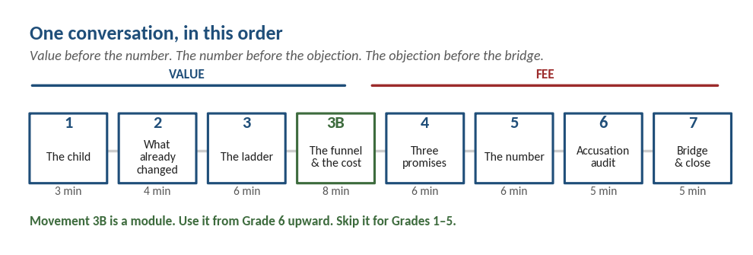
Print this and keep it in front of you. The order is the argument.

Movement 1 — The child, not the school (3 minutes)
“Before anything else — tell me about her. What does she do when nobody has given her anything to do?”
Then:
“And what do you find yourself correcting most often?”
Write the answer down in front of them. You will use it in Movements 4, 5 and 7. This one act signals that the meeting is about their child and not about the school’s cash flow — which is precisely what the parent is bracing for.

Movement 2 — What has already changed, with no ask attached (4 minutes)
“Before we get to why I asked you in — did you see that the exhibition was opened to the whole parent body this time, not just the presenting grade? And that we brought in an outside judge for the showcase? Those started in September. Nobody paid anything extra for them.”
Name only what has actually happened, with dates, in this parent’s own grade band. One real thing beats five planned ones. If nothing has landed yet in their band, say so plainly — borrowing another grade’s example is the kind of small dishonesty that gets found out in the WhatsApp group by evening.

Movement 3 — Why the school is changing at all (6 minutes)
This is the value core, and it is what makes the number a price rather than a demand. Draw the ladder on paper, bottom rung first, or use the printed sheet.
“Let me show you something before we talk about anything else. Every education system in the world is built on six levels of thinking. I will draw them, and you tell me where your child’s school day actually sits.”
Draw the six rungs. Then:
“These bottom three — remembering, understanding, applying a known method — are what exams test and what tuition drills. These top three — analysing, judging, creating — were until recently taught only to research scholars.”
Then the turn:
“In 2026, a free app on your phone beats every human being alive on all three of the bottom rungs. It does not forget, it does not tire, and it costs nothing. A school that spends twelve years perfecting a child on those three is training her for a race that is already finished.”
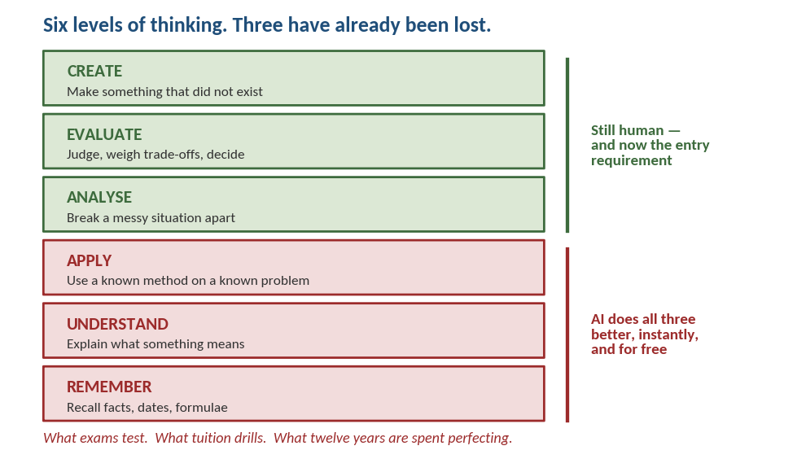
Draw this by hand if you can — a parent watching it appear remembers it. The printed version is the fallback.

Rung | What it means | Who is better at it in 2026
Remember | Recall facts, dates, formulae | AI — instantly, without error
Understand | Explain what something means | AI — in any language, at any level
Apply | Use a known method on a known problem | AI — faster and cheaper than any human
Analyse | Break a messy situation apart, spot what is wrong | Human
Evaluate | Judge, weigh trade-offs, decide with a conscience | Human
Create | Make something that did not exist before | Human

Close the movement with the cognitive point, in plain language:
“Estonia’s education minister put it well — the brain is lazy by design, because thinking burns energy. After every past upheaval people thought hard for a while and then settled back into habit. This time there is nothing to settle back into. Our children have to be trained to live at the top of that ladder, not visit it occasionally.”
Attribute this accurately — Kristina Kallas, Minister of Education and Research, Estonia, TEDx University of Tartu, June 2026. Parents will look it up, and being right is itself the credibility. Never add job-loss numbers; she makes no such claim and an unsourced figure is the one thing a parent will catch.
If the parent goes quiet here, do not rescue them. This is where the value case is either accepted or not, and it must be settled before any figure is mentioned.

Movement 3B — The funnel, the fallacy, and the real cost (8 minutes)
Use with Grade 6 and above, and with any family weighing a large CBSE school. Skip for Grades 1–5. This module converts the ladder from an abstract argument into arithmetic the parent already half-knows from their own neighbourhood.
The rule that governs the whole module: every number you use must be either the government’s or the comparison school’s own. HLC asserts nothing here. The moment you add an opinion about another school, you lose it.
Open by disarming the obvious suspicion:
“Can I show you something about the kind of school you are comparing us with? I am not going to say one word against it. Every number I use is either the government’s or theirs.”
Then the denominator move — the heart of the module:
“Every large school publishes how many of its students got into an IIT, an NIT or a top state engineering college. Almost none of them publishes how many children were in the graduating batch that year. Ask them for both numbers. They will give you both. Then you do the division yourself — I don’t have to.”
This is the single most effective sentence in the module. It costs nothing, attacks nobody, and cannot be answered. The parent will go and ask.
Now the national picture, which is public and verifiable:
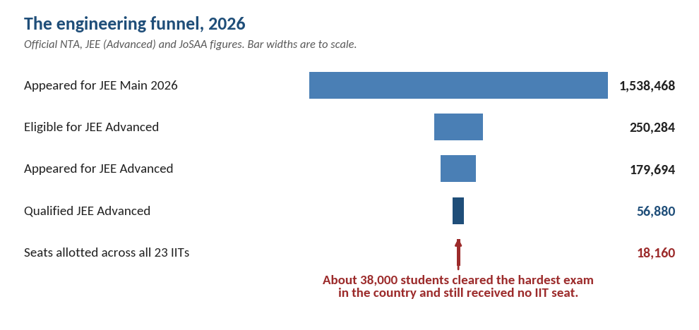
Every figure here is the government’s. HLC asserts nothing on this page.

JEE 2026 — the engineering funnel, official figures | Number
Registered for JEE Main 2026 (B.E./B.Tech paper) | 16,04,854
Unique candidates who appeared across both sessions | 15,38,468
Became eligible for JEE Advanced (top JEE Main scorers) | 2,50,284
Appeared for JEE Advanced | 1,79,694
Qualified JEE Advanced | 56,880
Seats allotted across all 23 IITs | 18,160
Qualified JEE Advanced but received no IIT seat | about 38,000

“Sixteen lakh registered for JEE Main this year. Fifteen and a half lakh sat it. Two and a half lakh made it through to JEE Advanced. Fifty-seven thousand qualified. And there are eighteen thousand seats across all twenty-three IITs. So roughly thirty-eight thousand children who cleared the hardest exam in this country still did not get an IIT seat.”
Then widen it honestly, so you are not accused of cherry-picking:
“Now add every NIT, every IIIT and every government-funded institute seat allotted through the same counselling — another twenty-five thousand or so. It is still a few in a hundred of the children who started.”
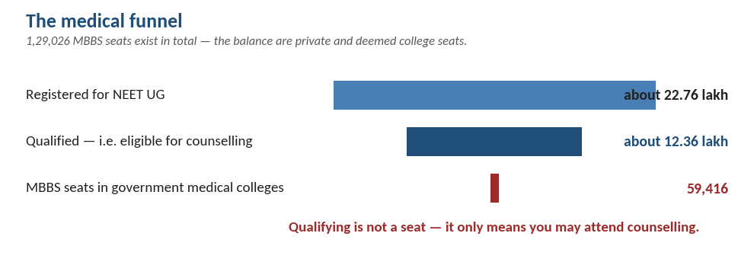

NEET — the medical funnel, official figures | Number
Registered for NEET UG (2025) | about 22.76 lakh
Qualified, i.e. eligible for counselling (2025) | about 12.36 lakh
MBBS seats in the 417 government medical colleges | 59,416
Total MBBS seats including private and deemed colleges | 1,29,026

“Medicine is narrower still. Around twenty-two lakh write NEET. There are about fifty-nine thousand MBBS seats in the government colleges. Qualifying is not a seat — it only means you may attend counselling. Fewer than five in a hundred aspirants end up with a government seat. The rest either stop, or pay for a private seat — and what a private MBBS seat costs is a completely different conversation about money.”

The three things a parent is not told
- “Cleared JEE” means three different things. Qualifying JEE Main, qualifying JEE Advanced, and actually receiving an IIT, NIT or top state college seat are three separate events, and schools advertise whichever number is largest. Ask which one is meant. This is a question, never an accusation.
- The numerator is published; the denominator never is. A hoarding shows the children who got in. It cannot show the batch they came from. This is not dishonesty — it is simply how the information reaches a parent, and it is why an intelligent person can be badly misled by a completely true advertisement.
- The cost is paid by everyone, not only by those who succeed. Published coaching fees run about seventy thousand to one and a half lakh a year, and a two-year classroom programme at one of the large institutes is advertised anywhere between roughly one point eight and four lakh — on top of school fees. Every family in the batch pays it. A small number of seats come out of the other end.
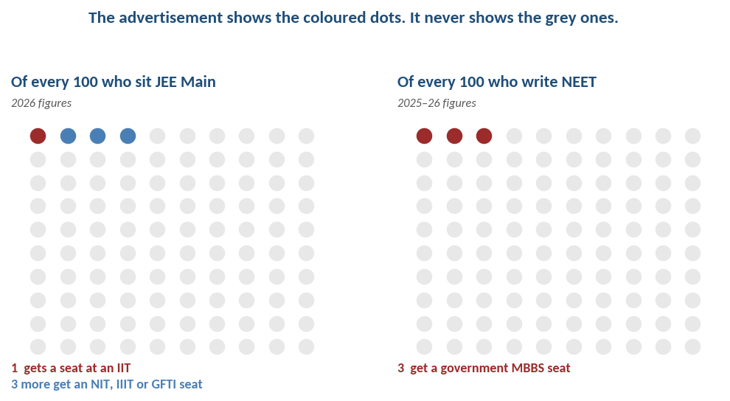
The strongest use of this page: hand it over and say nothing for ten seconds.

The cost comparison — the one version of it that survives
Read the guardrail first. Never claim HLC is cheaper. Over twelve years, with college added, it is not, and a parent who does the arithmetic will catch you. The argument below does not need that claim, and it is stronger without it.
The parent’s mental model is “cheap school” versus “expensive school.” That model is wrong in a specific, demonstrable way: the cheap school is one of three bills, and the parent only ever sees the first.
Start with the two years where the comparison is genuinely like for like:
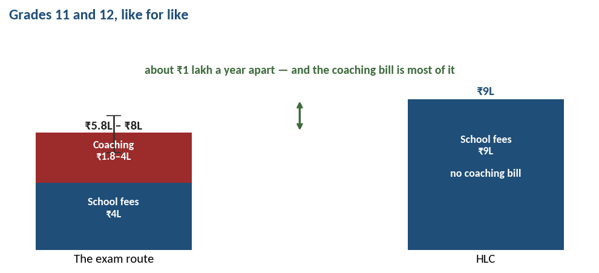

Grades 11 and 12, two years | The exam route | HLC
School fees | about ₹4,00,000 | about ₹9,00,000
Coaching, two-year programme | ₹1,80,000 – ₹4,00,000 | nil
Total over the two years | ₹5,80,000 – ₹8,00,000 | ₹9,00,000
The child’s two years | Twelve-hour days, one subject group | A school day, interests kept

“Look at what is actually different in those two years. It is about a lakh a year. And your coaching bill alone is most of that lakh. The gap between the two routes at this stage is far smaller than the fee letters make it look — because one of those two bills arrives from a coaching institute rather than from a school, so it never gets added in.”
This is the like-for-like comparison and the only cost table a counsellor should put in front of a parent. Never place two years of school beside four years of college — that is the sleight of hand a sharp parent spots, and spotting it costs you everything else you have said.
Then the third bill, which is the biggest and the least planned for:
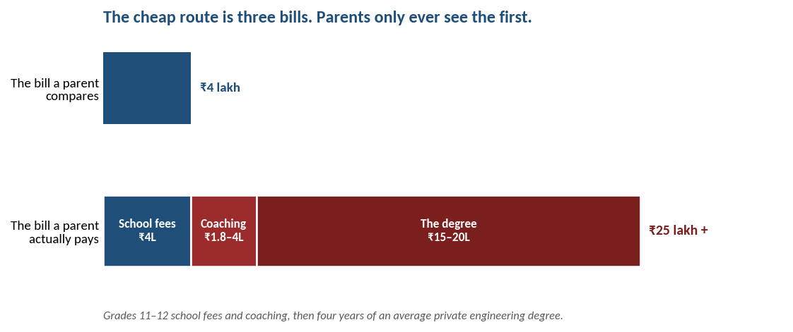
The first bar is what a parent compares. The second is what a parent pays.
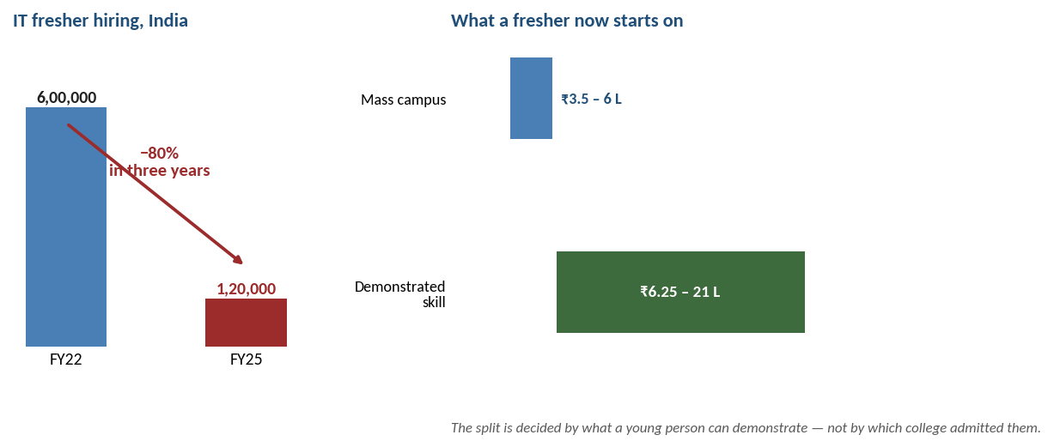

The bill nobody plans for | What the published figures show
An average private engineering degree, four years | roughly ₹15–20 lakh
IT fresher hiring, FY22 peak | about 6,00,000 a year
IT fresher hiring, FY25 | about 1,20,000 — an 80% fall in three years
Entry-level openings, year on year | down 44%
Engineering graduates produced each year | about 15,00,000
Mass campus salary track | ₹3.5 – 6 lakh a year
Demonstrated-skill / specialist track | ₹6.25 – 21 lakh a year

“The largest single cheque in this whole journey is the last one — fifteen to twenty lakh for a degree. It is bigger than all twelve years of school fees that came before it. And it is written at the worst possible moment: in August, in a hurry, after a result, with no leverage at all.”
Then the point that matters most, and the one the parent’s own career makes credible:
“And ask what that twenty lakh buys now, compared with what it bought when we started out. In 2022 the IT industry took about six lakh freshers a year. By 2025 it was about one lakh twenty thousand — an eighty per cent fall in three years. Entry-level openings are down forty-four per cent year on year. And the country still produces around fifteen lakh engineering graduates every year. The degree has not stopped being a degree. It has stopped being a queue ticket.”
Then the line that closes the module: “And look at what the hiring has split into. The mass campus track is three and a half to six lakh a year. The demonstrated-skill track is six to twenty-one. What decides which side of that line a young person lands on is no longer which college admitted them. It is what they can actually show they can do.”

“So what do your alumni earn?” — the question you cannot answer with a number
Expect this within seconds of the salary table. It is the fair counter, and a counsellor who is not ready for it undoes the whole module. Do not improvise here — use these words.
“That is exactly the right question to ask me after everything I have just said, and I want to answer it properly rather than slide past it. I do not have that number. And I am not going to build one for you, because at our size it would not mean anything. We graduate a small cohort every year. One of them joins a bank, one does a PhD, one starts a company — and an average across those three tells you nothing about any of the three. A figure like that, from a school this size, counting only the people who bothered to reply, is a marketing number. I would rather lose this argument than hand you one.”
Then turn it — the same denominator move used earlier in this module:
“And before you accept a number like that from anybody else, ask them three things. How many children were in that graduating year. How many of them replied. And who did the collecting. Very few schools in this country can answer all three.”
Then offer what is real, and lead with the things that do not require trusting HLC:
- Cambridge results as a multi-year trend line. Externally set, externally marked, not self-reported. This is the one academic claim we make that nobody has to take our word for.
- Named alumni the parent can look up. Yash Rajeshwar, Laya Shankar, Abhay Menon. Names are checkable; adjectives are not.
- Ventures that outlived the school. MUN Tutor and Go Paadhai started here as learner-led incubations and kept running after those students left. A business that survives its founder’s graduation is evidence of a different kind.
- Named external partners. Inklink Charitable Trust and Maatram Foundation are credibility anchors precisely because they are not HLC talking about itself.
Then make the offer that actually closes it:
“And here is what I would most like you to take instead of a statistic. Three phone numbers — an alumnus, and a parent whose child has already left. Call them without me in the room and ask them anything you like. I would rather you did that than believe any average I could quote you.”
An unscripted introduction beats a number, and it costs nothing. Ask the alumnus first, every time, and never brief them on what to say — a coached call is worse than no call, and a parent can hear the difference in thirty seconds.
Then the reframe — offered, not insisted on:
“And there is one more thing I would say, though you are free to reject it. A first salary at twenty-two tells you a great deal about a college’s placement cell and rather less about a school that stopped teaching the child four years earlier. What a school can honestly be held to is what your daughter is like at eighteen — what she has built, what she has led, and whether she can stand up and defend it in front of a stranger who has no stake in her. That I can show you this term, with her own work.”
Then the commitment, which converts the weakness into a dated promise:
“And from this year we are building the register properly — every graduate, every destination, complete, not only the ones who reply. I would rather tell you in three years what it actually says than tell you today what I hope it says.”

Guardrails on the alumni question
- Never quote an alumni salary figure. Not an average, not a range, and never a single graduate’s package offered as if it were typical. One impressive number invites a parent to ask for the other twenty-nine.
- Never say “our alumni are doing very well” without a name attached. An unnamed success claim is exactly what a sceptical parent discounts to zero, and it costs you the credibility you just earned by conceding the number.
- Never say “we don’t measure that” and move on. It sounds evasive. Say why the measure would be poor at our size, then immediately offer what you do have.
- If the parent presses for a number anyway, hold. “I know that is unsatisfying. I would rather be unsatisfying than wrong.” Then go straight to the three phone numbers.
Action for management: the one statistic a school this size can produce honestly is not salary — it is a complete destination list. Every graduate, every year, university and course, with no gaps. Completeness is what makes a small number credible: a full list for thirty students is worth more than an average salary built from a forty per cent response rate. Start it this year and back-fill the last three. It is the highest-value item in the alumni work and it retires this objection permanently within one cycle.

Then be honest about our own price — this is what makes the rest believable
“So let me be straight with you about HLC. Over twelve years we are not cheaper. We are more expensive, and I am not going to pretend otherwise — you would catch me on it in five minutes anyway. Two things I will say. In Grades 11 and 12 the gap between us and the coaching route is about a lakh a year, which is roughly what the coaching itself costs. And the twenty lakh that comes afterwards gets spent either way. What we are trying to change is which side of that three-and-a-half-versus-twenty-one-lakh line your child stands on when she gets there — because that line is now drawn by what she can demonstrate, not by which college let her in. That is the only reason I think we are worth more.”
Conceding the price openly is what buys belief for everything around it. A counsellor who claims HLC is cheaper is making the one argument in this entire pack that can be disproved with a calculator.

The belief arithmetic — the line that lands hardest
“Here is the part nobody says out loud. On admission day, in that hall, every family is planning around the advertised number. The advertised number does not multiply to match the number of families planning around it. That is not a comment on anybody’s child. It is a seat count.”
Say it exactly like that, and then stop. Do not soften it and do not extend it. The parent finishes the thought themselves, which is the only way this argument survives.
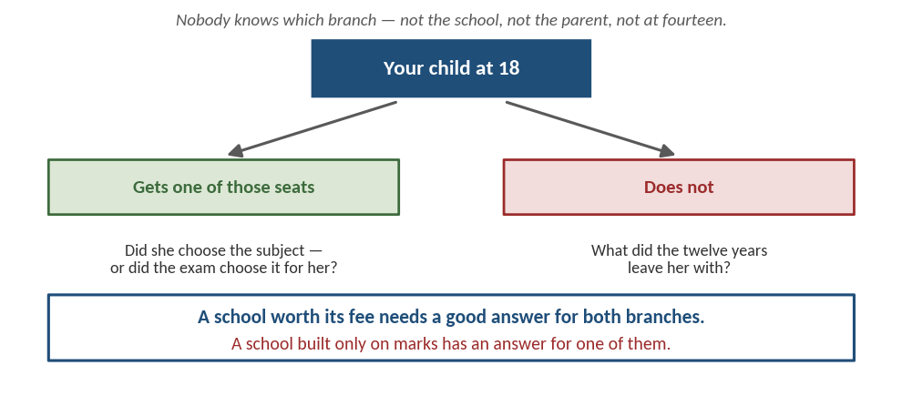
This is the safety catch of the whole module. Show it rather than argue it.

The two-branch move — never tell a parent which group their child is in
This is the safety catch on the entire module. Any hint that their child is in the larger group is insulting, unprovable, and will cause the parent to reject everything else you have said in order to defend their child. Use the two branches instead.
“I don’t know whether your child ends up in the group that gets one of those seats or the group that doesn’t. Neither does that school. Neither do you — not at fourteen. So the only question I think is worth asking is: what happens to her in both cases? A school worth its fee needs a good answer for both branches. A school built only on marks has an answer for one of them.”

Then the reversal — this is where the fee lands
“And notice that you are already going to spend this money. School fees plus two years of coaching is not a small number in any version of this. We are not asking you to spend more than that. We are asking you to spend it on the child rather than on the ticket.”
Close the module with a question they take home and ask themselves:
“Ask that school one more thing. Of all the children who went on to ordinary colleges — what did the twelve years leave them with? If the honest answer is a mark sheet that stopped mattering the week the result came out, that is exactly the gap we exist to fill.”

Guardrails for this module — read before using it
- Never name another school, cite its figures, or dispute its claim. Ask for its denominator. That is all.
- Never tell a parent which group their child is in, in either direction. Not even encouragingly.
- Never say “rat race”, “herd” or “following the flock”. The parent made that choice, or is about to, and those words make them defend it. Frame it as a trap no single family can exit alone — which is true, keeps their dignity, and is precisely the argument for what a school can do that a parent cannot.
- Never raise student suicides or student deaths in this conversation. It is the most powerful thing in the argument, which is exactly why using it to close a fee conversation reads as scaremongering. You also cannot know which family in front of you has a child already struggling, or has been touched by it. In the room, speak only about stress in ordinary terms — twelve-hour days, two years of adolescence, an interest abandoned at fifteen. Anything harder belongs in written orientation material, stated soberly, never attached to a named school, and never as the last thing a parent hears.
- Never claim HLC costs less overall. It does not. Compare two years against two years — never two years of school against four years of college. The moment a parent catches that substitution, every other number you used becomes suspect.
- Verify the figures before each admissions cycle. These change every year. A counsellor quoting last year’s seat count to a parent who has just read this year’s is finished.
- If the parent has a child already in a coaching programme, do not use this module at all. Move to Movement 4. Telling a parent mid-investment that the investment is poor produces defensiveness, not reflection.

Movement 4 — The three promises, at this child’s grade (6 minutes)
Never describe the roadmap in general. Attach every promise to the child’s name and to the interest named in Movement 1.

Promise 1 — We find what she loves, and we back it
“Most schools treat an interest as a distraction from studies. We treat it as the starting point. Our job in the first year is to find out what she is genuinely drawn to, and then protect it rather than squeeze it out.”
Tie to the ladder: “The top rung is Create. Nobody creates anything worth creating in a subject they do not care about. Finding what she loves is not a soft extra — it is the raw material.”

Promise 2 — Academic excellence, built around that love
“This is not a school that trades marks for happiness. Our academic standards are high and not negotiable. The difference is the route. A child who loves [her interest] learns her science through it, works harder at it, and stops studying out of fear. Marks earned that way do not collapse the moment the exam ends.”
Tie to the ladder: “You cannot analyse a subject you do not know. We still build the bottom three rungs properly. We simply refuse to stop there, the way a marks-only school has to.”
Tie to the funnel, if 3B was used: “And notice this promise works on both branches. If she is competing for one of those seats, she needs the rigour. If she is not, she still leaves with something. That is the whole design.”

Promise 3 — She leaves as a leader, not just a candidate
“Responsibility means doing what you were told. Leadership means others follow you when nobody told them to. Over the years here we give her the platforms — leading a team, owning a project, standing in front of people — so that at twenty-eight she is the one others look to.”
Tie to the ladder: “AI can draft the presentation. It cannot stand in the room and carry it. Judgement and responsibility for a decision are the last things to be automated, and the hardest to begin learning at twenty-five.”
Then make it concrete for their band. For Grades 1–8(9):
“For her specifically, this year: a written Learning Story each term — a real, dated account of one moment of her growth, not a checklist; a student-led conference where she presents her own work to you instead of me talking about her; documentation panels outside the classroom so you can see a project in progress at pickup; and teacher training in stretching a child through feedback and structure rather than more homework.”
For Grades 9–12:
“For him this year: external judges from outside HLC at Knowledge Fair and Shark Tank, so his work carries a benchmark a college can read; the expert engagement series mapped to his subject combination; the alumni mentor network for his applications; and deeper college counselling and LOR work.”

Movement 5 — You put the number on the table (6 minutes)
Never let the parent raise it first. A number you volunteer is a decision; a number they have to drag out of you is a concealment, and they will treat it as one.
“Now — you will have seen the circular, or you will shortly. Let me show you exactly how that figure was built, because the headline number is the least useful way to look at it.”
Put the table in front of them. Walk both columns.
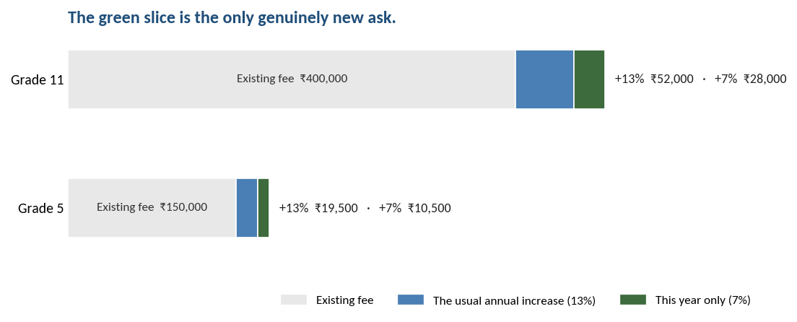
Show the picture first, then the rupee table. The eye settles the argument before the arithmetic does.

 | Grade 5 daughter | Grade 11 son
Current annual fee | ₹1,50,000 | ₹4,00,000
The usual annual increase (13%) | ₹19,500 | ₹52,000
This year only, the addition (7%) | ₹10,500 | ₹28,000
Total increase (20%) | ₹30,000 | ₹80,000

“Thirteen per cent is the increase you have seen from us before and would have seen this year regardless. Seven per cent is new, it is for this year only, and it funds the specific list I have just walked you through. From next year we return to the usual annual increase.”
Then volunteer the unflattering half, every time: “Returning to normal means the rate of increase goes back to normal. It does not mean this year’s fee reduces next year. I would rather you hear that from me now than feel misled in twelve months.”
Volunteering the clause that does not help you is what buys belief for the clause that does. Counsellors who skip it to keep the meeting pleasant are trading a comfortable twenty minutes for an angry October next year.
The line that does the most work: “The percentage is identical for both your children, and identical to every other child in this school. Once you separate the usual increase from this year’s addition, the genuinely new ask across both of them is ₹38,500 — not ₹1,10,000.”

Movement 6 — The accusation audit (5 minutes)
This is the difficult part of the conversation and the one most likely to be skipped. Do not skip it. Said by you it dissolves; left to the parent it hardens into a grievance that outlives the fee.
“There is something I want to put on the table before you have to. You have a child in Grade 11. A large number arriving in a board year can look like it is being asked precisely because you cannot move him now. If I were sitting where you are, that is exactly what I would be thinking.”
Then, immediately, the evidence:
“So here is the check. It is the identical percentage a Grade 1 family is paying. The rupee amount is larger only because his fee was already larger. And of the ₹80,000, ₹52,000 is the ordinary annual increase. The new part is ₹28,000.”
Then answer the question they were about to ask, before they ask it — the four deliverables from Movement 4.
If they go quiet, let the silence sit. This is the moment the grievance either forms or dissolves, and it dissolves in silence, not in more talking.
If they are visibly upset, label it and stop: “It sounds like the timing is what stings, more than the amount.” Then wait. Do not add a second sentence.

Movement 7 — The bridge, and the close (5 minutes)
For a multi-child household these are the most important ninety seconds in the meeting. They are aimed at the younger child, who is the one actually at risk.
“One last thing, and it matters more than anything else I have said. Because you have two children with us, there is a sibling benefit on the increase — and it runs for as long as they are both here, not just this year. It is not a concession on this hike. It is a standing arrangement for your family.”
Then offer the rest of the bridge without making them ask:
“And if the timing of the payment is difficult, that is a conversation with [named senior contact] and it is handled privately, one-to-one. You do not have to raise it with me or with anyone else here.”
Then close:
“I would rather you went home and checked every number I have given you than took my word for it. If anything does not add up, call me — not the office. And whatever you decide about the fee, nothing changes about how she is looked after here.”
That last sentence is not decoration. The parent’s real fear in a fee conversation is that objecting will cost their child something. Remove that fear explicitly, in words, or it stays.

PART D — Five scenarios
Each of these is a real pattern, not a hypothetical. Read the one you are about to walk into.

Scenario 1 — The two-child IT household (Grade 5 and Grade 11)
What is actually happening: they are recomputing EMIs at the kitchen table. Fees are approaching 35–40% of gross household income. The Grade 11 son is staying regardless and they know it; so do we. The real event is that this is the week they start quietly asking about the CBSE school for the daughter.
- Lead with: the arithmetic table and the sibling benefit. Do not lead with the roadmap.
- Do the accusation audit early, in Movement 6 as written, and do it about the son even if they have not raised him.
- Use Movement 3B for the son, not the daughter. A Grade 11 parent is inside the funnel already and will recognise every number. A Grade 5 parent is not, and it will read as scaremongering. Use it once, for the older child, and let it carry both.
- Spend more time on the daughter than on the son. Counter-intuitive, and correct. The son is not the decision; she is.
- Close by naming her three adults out loud. This is the one thing the cheaper school cannot match, and it is the thing that survives the drive home.
Success looks like: they leave able to explain the 13/7 split to someone else. If they cannot repeat it, the meeting failed regardless of how warm it felt.

Scenario 2 — The Grade 12 parent: “what changes for my child?”
The honest problem: most of the funded roadmap is multi-year and this child leaves in months. Do not disguise that. Attempting to sell a three-year roadmap to a final-year parent is how a fair question becomes contempt.
“You are right that a lot of what this funds is a multi-year build, and your son will not see most of it. I am not going to pretend otherwise. What he will see, this year, is four things — and if any of them does not happen, I want you to come back to me by name.”
Then the four: external judges at Knowledge Fair and Shark Tank, the expert engagement series mapped to his subjects, the alumni mentor network for his applications, deeper college counselling and LOR work.
- Add the honest second half: “Some of what you are paying builds a school your son leaves behind. If that feels unfair, say so and I will take it up rather than argue it. What I can tell you is that the alumni network he joins is the same one we are formalising — it runs both ways.”
- Do not use Movement 3B here. This family is already mid-investment in the exam route. The funnel arithmetic arrives too late to be useful and lands as a criticism of a decision they cannot now reverse.
A final-year parent who is levelled with becomes an alumni advocate. One who is sold to becomes a story other parents repeat.

Scenario 3 — The junior-grade family actively pricing CBSE
Where the flight risk actually lives. Grades 1–8 can move with the least disruption. This family is not angry; they are doing arithmetic.
- Concede the price point immediately and completely. “On price that comparison is over. We lose it. I am not going to argue about fees with you.” A counsellor who contests this is not believed on anything afterwards.
- Then move the comparison. Three named adults, the promoter meeting, the looping mentor, one person to call for anything. Say the names out loud. Offer to write them down.
- Use Movement 3B only from Grade 6 upward. Below that, the single denominator sentence is enough on its own: ask the other school for its graduating batch size alongside its selection count. Nothing more.
- Pre-empt the Finland objection before they get there: small ratios exist in free systems too, so the ratio is not the argument — the rituals built on top of it are.
- Invite verification: “Come in unannounced, any weekday, and watch a class. No appointment. That offer is not available at most schools for a reason.”

Scenario 4 — The parent who says “fine” and leaves
The most dangerous conversation in this pack, and the one most counsellors will record as a success. A conservative Chennai parent does not argue in the room. Agreement offered quickly and without questions is usually not agreement.
Do not let it end there. Use a soft probe:
“You have been very gracious about this, and I would honestly rather you weren’t. If there is a version of this you think is unfair, I would like to hear it now rather than find out in June.”
Or, better, invite the objection directly:
“Most parents I have spoken to have had at least one hard question about this. What is yours?”
Asking for the objection is the single highest-yield move available with this parent body. A parent who leaves with an unspoken objection takes it to the WhatsApp group instead, where you cannot answer it.
- Flag it internally the same day. A silent multi-child family is a higher risk than a loud one.

Scenario 5 — The organised group or joint representation
Read it correctly: a joint letter is not an attack. In this city it is the polite, low-risk form of raising a concern — safety in numbers, and a signal that it is not a personal grudge. Treating it as hostility is what escalates it.
- Never discourage it, never appear rattled, and never ask who else signed.
- Respond in writing, numbered, point by point, within 48 hours, from a named senior person. Never telephone instead — a phone call in response to a written letter reads as avoiding the record.
- Answer the three standard questions head-on: what is this funding for my child’s grade specifically, is there a sibling or continuing-family consideration, and can it be staggered.
- Offer to meet a small delegation with the itemised breakdown in front of you. Schools that have opened the numbers have defused these. Schools that said “inflation” have ended up in the press.
- If the fee regulation framework is mentioned, do not become defensive. “We are happy to share the full breakdown — I will send it whether or not anyone asks formally.” Transparency offered voluntarily removes the leverage entirely.
- Never use Movement 3B in a group setting. It needs the two-branch safety catch, and that only works one family at a time. In a room of twenty, somebody will hear it as a verdict on their child.

PART E — Every objection, with the exact words

The parent says… | You say…
“Holistic means marks will suffer.” | “Ask me for our Cambridge results as a trend line and our placements — I will show you the numbers, not adjectives. We do not dilute academics. We change what powers them.”
“All this is fine, but competition is real.” | “Agreed, and we do not remove it. We make sure your child competes where she is strongest instead of where everyone else already is.”
“My child doesn’t love anything yet.” | “At this age very few do. Finding it is our work — it is not homework you take home.”
“Less homework means lower standards.” | “That is the right worry, and it would be true if we simply removed work. What we are funding is teacher training in assessment design — fewer, harder, better-designed pieces. The training is happening first, before the homework changes. If you see the second without the first, hold me to it.”
“AI is over-hyped. Doctors and engineers will always be needed.” | “Absolutely. The profession survives; the routine part of the job does not. The doctor who is only good at recalling and applying is replaceable. The one who can judge, decide and lead is not.”
“But that school got fifty into IIT last year.” | “I believe them, and I am not going to dispute it. Ask them one more number — how many children were in that graduating batch. Both numbers are theirs, not mine. Once you have both, you have done the arithmetic yourself and I have not said a word against anybody.”
“So you are saying my child won’t get into an IIT?” | “No. I have no idea, and honestly neither does anyone else at this age. What I am saying is that I would not build twelve years of a child’s life on the assumption either way. The question I would ask is what she is left with in both cases.”
“You are just running down another school.” | “If it sounded that way I have said it badly, and I am sorry. Every figure I used is either the government’s or that school’s own. I have no smaller a wish for those children than you do. My point is only about which group a family plans for.”
“What do your alumni actually earn?” | “I do not have that number, and I am not going to build one — at our cohort size an average would be a marketing figure, not a fact. Before you accept one from anyone else, ask them how many graduated, how many replied, and who collected it. What I can give you instead is our Cambridge results as a trend line, alumni you can look up by name, ventures that kept running after those students left, and three phone numbers you can call without me in the room.”
“So you are saying HLC works out cheaper?” | “No. Over twelve years we are more expensive, and I am not going to pretend otherwise. Two things are true though. In Grades 11 and 12 the gap between us and the coaching route is about a lakh a year — roughly the coaching bill itself. And the fifteen to twenty lakh for a degree gets spent either way. What we are trying to change is what that degree is worth when she gets there.”
“My child will do engineering and join an IT company, like I did.” | “That is exactly the route that worked for us, and it worked because the industry took about six lakh freshers a year. By 2025 that was about one lakh twenty thousand. The profession is fine — the queue your generation joined is not there any more. That is not my opinion; it is the industry’s own hiring data, and you probably see it inside your own company.”
“Everyone takes coaching. My child will fall behind without it.” | “You are right that no single family can opt out alone — that is exactly what makes it a trap rather than a choice. It only changes when a whole cohort is measured differently. That is the one thing a school can do and a parent cannot do at the kitchen table.”
“Last year was 10%, not 13%.” | “Let me check that against your actual circular rather than argue from memory — mine or yours. I will come back to you with the exact figure by tomorrow.” Then do it. Never defend a baseline you have not verified for that family.
“A lakh, in his board year. You know I can’t move him.” | “I would have the same thought in your position, so let me put the arithmetic in front of you rather than ask you to trust me. It is the identical percentage a Grade 1 family is paying. The rupee figure is larger only because his fee was already larger. And of that ₹80,000, ₹52,000 is the increase you would have seen in any year — the genuinely new ask on him is ₹28,000.”
“What changes for HIM this year? He leaves in eighteen months.” | “Four things, all inside this academic year: external judges from outside HLC at Knowledge Fair and Shark Tank so his work carries a benchmark a college can read; the expert engagement series mapped to his subject combination; the alumni mentor network for his applications; and deeper college counselling and LOR work. If any of those four does not happen, come back to me by name.”
“So next year it will be 20% again.” | “No. The 7% is for this year and this purpose only; from next year we return to the usual annual increase. And to be precise, because parents have misheard this: the rate goes back to normal — this year’s fee does not come down.”
“Can you stagger it over two terms?” | “Let me take that to [named senior contact] rather than answer it at the gate. There is a private channel for families who want to discuss payment, handled one-to-one.” Do not promise an instalment. Do not describe the 75% rule. Route it.
“I have two children here. Does that count for anything?” | “Yes, and this is the part I most want you to hear. There is a sibling benefit on the increase, and it runs for as long as both children stay with us — not one year. It is not a concession on this hike; it is a standing arrangement for your family.”
“What is this actually funding? Don’t say infrastructure.” | “I won’t, because it isn’t. Teacher training in assessment design, an external expert calendar, external judges at showcases, the Learning Story notes, and protected time to write them. I will show you the line-by-line sheet for your child’s grade band.”
“Some of us are thinking of writing jointly to the management.” | “That is entirely your right and I will make sure it reaches [named senior contact] the same day. I would still rather answer your three questions first, today, and let you decide afterwards.” Report internally the same day. Never discourage it. Never appear rattled.
“The CBSE school two streets away costs a third of this.” | “It does, and on price that comparison is already over — we cannot win it and I will not pretend otherwise. What that school cannot do is tell you the names of the three adults who track your daughter. Can I give you those three names now?”
“Finland has small classes for free. Why does 30 per section cost this much?” | “That is the sharpest version of the question and it is fair. The ratio is not the product. What the ratio makes possible is: three named adults per child, a promoter meeting every child once a year, the same mentor staying with a cohort for years, and one person you call for anything. Those are checkable. The number 30 by itself is not the argument.”

PART F — Guardrails

Nine sentences that must never be said
- “Inflation.” “Rising costs.” “Infrastructure.” A vague answer is the documented trigger for joint representations in this city. Specific, or say nothing and route it.
- “Every school is increasing fees this year.” It invites the parent to go and check what every other school actually did.
- Any rupee figure without its percentage beside it. Especially in Grades 9–12, where a flat number is what makes the ask read as leverage.
- “You are of course free to consider other options.” Never, in any tone, to any parent, under any provocation.
- “Don’t worry, we can work something out.” You are not authorised to. Route it, and say you are routing it.
- “The fee will come down next year.” It will not. The rate of increase returns to normal. Anything looser is a promise the school will be held to, verbatim, next October.
- Any named school’s results, in any direction. Do not quote them, do not dispute them, do not praise them. Ask for the denominator and stop.
- “Rat race.” “Following the herd.” “Like sheep.” The parent is inside that choice. These words make them defend it instead of examining it.
- Any reference to student suicides or student deaths. Not in a fee conversation, not in an admissions conversation, not as an aside. See the guardrails in Movement 3B.

The first forty-eight hours
The circular’s real audience is a WhatsApp group, not an inbox. Parents compare figures before anyone contacts the school.
- Identical explanation, identical words, every family in a grade band. Inconsistency is discovered within hours and reads as either improvisation or favouritism — both fatal.
- Assume every sentence is screenshotted. Say nothing you would not put in writing.
- Multi-child and legacy households are contacted personally before the circular lands.
- Never discuss another family’s discount, scholarship or arrangement, even to reassure. Route every such question to the named senior contact.
- Have the itemised grade-band breakdown ready to send the same day it is first asked for. A 24-hour delay is read as drafting a defence.

Report the same day, not at the end of the week
- Any mention of the Tamil Nadu fee regulation framework, the Fee Regulatory Committee, or the press.
- Any mention of “some of us”, a joint letter, or a group of parents.
- Any enquiry about Transfer Certificate timelines, however casual.
- Any multi-child family that leaves still feeling the senior grade was targeted. The older child will stay; the younger one is being priced elsewhere that evening.
- Any family that agreed immediately and asked nothing.
- Any parent who reacts to Movement 3B with distress rather than interest, or who mentions a child under strain. Stop the module, stay with the parent, and tell Naveen or Raaji the same day.
- Any question you could not answer. An unanswered question reaching the group before our answer does is worth more damage than the question itself.

PART G — Short forms

The two-minute version, at pickup
“The percentage is the same for every child in the school — yours, mine, Grade 1 to Grade 12. Most of it is the annual increase you have seen before. Seven per cent is new, it is for this year only, and it funds a specific list I can show you. If you have two children here, there is a sibling benefit that runs for as long as they are both with us. And some of what it pays for has already started — you saw it at the exhibition. Come and see me properly this week and I will take you through your own two numbers.”

The one-minute value version, if there is no time for the ladder
“Schools have spent two hundred years training children to remember, understand and apply. A free app now does all three better than any human alive. What is left for our children is to analyse, to judge and to create — and none of that grows in a child who is only being drilled for marks. We help your child find what she loves, we build real academic strength around it, and we send her out able to lead. Marks alone were enough in our generation. They will not be enough in hers.”

The one-sentence version of Movement 3B
“Every school publishes how many children got into an IIT, an NIT or a top state college. Ask them for one more number — how many were in the batch. Both numbers are theirs, and the arithmetic is yours.”

The sentence to end on, whichever version you used
“Whatever you decide about the fee, nothing changes about how she is looked after here.”

PART H — What is still open
Three items in the underlying pack are unresolved and will surface in parent conversations. They are listed here so no counsellor is caught by them.
- The baseline percentage conflict (13% in the plan, 10% in at least one parent’s memory). Until verified, counsellors should not assert a prior-year figure at all.
- Whether the 5% scholarship cap applies to the 20% or the 7%.
- The alumni destination register. This pack commits counsellors to telling parents that a complete register is being built from this year. It is currently a Phase 3 item. Either start it now and back-fill three years, or remove the promise from the script — it should not be said to parents until management has committed to it.
- The commitment to revert next year. This pack requires counsellors to make that promise personally, face to face, to roughly four hundred families. It converts a line in a planning memo into several hundred individual commitments that will be quoted back verbatim. Management should confirm it is held as a constraint on next year’s planning cycle before this script is issued.

Sources for the Movement 3B figures
Every figure in Movement 3B is drawn from published, checkable sources. None of it is HLC’s estimate, and counsellors should say so.
- JEE Main 2026 registration and appearance figures, and JEE Advanced eligibility: National Testing Agency, Session 2 results announcement, April 2026.
- JEE Advanced 2026 appeared and qualified figures: JEE (Advanced) 2026 results press release, 1 June 2026.
- IIT seats allotted: Joint Seat Allocation Authority (JoSAA) 2026 counselling, final round, July 2026. NIT, IIIT and GFTI seat counts are from the same counselling process.
- NEET UG registration and qualification figures, and MBBS seat matrix: National Testing Agency and the National Medical Commission seat matrix for 2026–27.
- IT fresher hiring volumes (an FY22 peak of about 6,00,000 falling to about 1,20,000 in FY25), the 44% year-on-year fall in entry-level openings, and the split between the mass campus track and the demonstrated-skill track: Xpheno talent-analytics data and company disclosures reported through 2026.
- Annual engineering graduate output of roughly 1.5 million: industry hiring analyses, 2026.
- Private engineering degree costs are a range, not a published figure. State a range, never a precise number, and say that it is a range.
- Coaching fee ranges: the institutes’ own published and advertised fee structures for two-year classroom programmes, 2026.
Verify all of these before each admissions cycle. They change annually, and a counsellor quoting a stale figure to a parent who has just read the current one loses the room.

Source material for the rest of the pack: HLC Fee Hike — Parent Communication Action Plan; HLC Value Upgrade & Fee Justification; the parent reaction memo; the Activities at HLC register (three worksheets); and Kristina Kallas, “When AI Knows Everything, What Should Humans Learn?”, TEDx University of Tartu, June 2026. Figures in the fee arithmetic table are illustrative, derived from the reaction memo — replace with actual grade-band figures before briefing.

